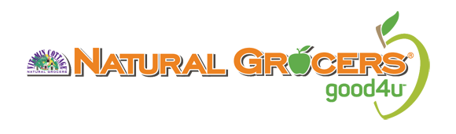
Hello,
Thank you for reaching out. We are always interested in partnering with local brands. To be considered, all products must meet our high-quality product standards. Go to www.naturalgrocers.com, click on Our Products and view our standards by category prior to submitting to Natural Grocers.

To get started, please answer the questions below and send the requested information via email:
- Do you have UPC codes on your packaging?
- Do you have at least a 1 Million liability insurance coverage policy and could add Vitamin Cottage Naturals Food Markets, Inc as additional insured?
- Do you work with a distributor?
- Would you ship or deliver product direct to stores?
- Would shipping or delivery cost be built into the cost of products for freight?
- Would there be an order minimum cost?
- Would there be enough product to supply the store on a consistent basis?
  - How many locations can you service?
    - Click here for a list of locations.
- Do you use a commercial kitchen that has been inspected by the county and state?
- Please send an excel spreadsheet listing each item you are presenting and include the following: brand name, UPCs, item description, size, case count, pricing and SRP?
- Send a full ingredient list.
  - We only sell natural and organic products with clean ingredients. For a listing of ingredients, we don’t carry, please click here.
  - Once your ingredients have been reviewed and are in line with our quality standards, we will request live samples to be shipped to our office. Your products will then be presented to our New Items Approval Committee.

Due to the overwhelming volume of new product submissions, we cannot guarantee you will receive a quick response. Providing complete and accurate information in your response can help to expedite the process. Please do keep in mind that products are reviewed monthly and it may take a few weeks before you receive an update. Please refrain from contacting us directly after your submittal – we will reach out to you.
Thank you,
Jessica Veit

