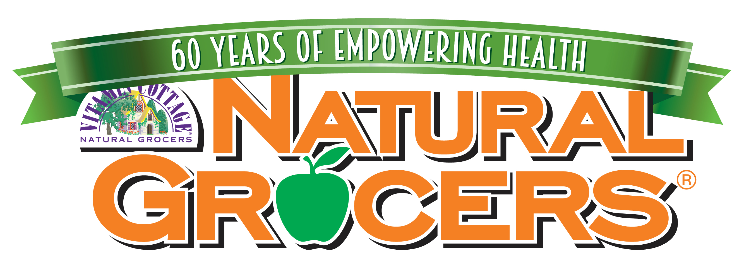

Supplement Company Questionnaire v20

Company Name:

Date Completed:

Completed By (name & position):

**Typically a quality control person would be the best to complete this questionnaire.

The following questionnaire is a requirement for Natural Grocers (NGVC) to review/consider supplements for approval. Also required is a full product sample (no mockups please), a completed submittal form, and a certificate of liability insurance (**at this time NGVC does not need to be listed on a COI. A copy of a current COI would be suitable for review purposes). All questions need to be answered. Product will not be approved without this completed questionnaire and above requirements. Feel free to include other pertinent information not covered here.

Email all documents to Vitamins Mailbox vitamins@naturalgrocers.com

Please do not submit product for review if they contain any of the below ingredients. These products will automatically be rejected from the review process. Please note, NGVC continually investigates ingredients and updating NGVC’s Supplement Ingredients We Won’t Sell and Why document. Previously approved ingredients may no longer be suitable. Please visit naturalgrocers.com/what-we-wont-sell-and-why for a full list of ingredients. Please note, any product reformulations to align with NGVC quality standards in no way obligates NGVC to approve product. Items will still have to complete the full review process.

Artificial colors

Artificial flavors

Hydrogenated and/or partially hydrogenated oils

Talc

Titanium dioxide

Natural flavors – at this time we will still accept products for review with this listing. It is preferred to see products with “organic natural flavors”. In the future, we will require a full panel discloser of any ‘natural flavors’ listed; where they are sourced from as well as all adjuncts, preservatives, flavor carriers, processing aides, and flavor enhancers within the ‘natural flavors’ listed on the product.

Has the manufacturer been certified by a third party such as NPA, NSF, USP? If yes, please provide documentation.

Are you listed as a GMP Certified Company? If not listed as GMP certified, has the facility or the contract manufacturer been audited for GMP?

If not listed as a GMP Certified Company outline the quality steps taken both in manufacture and distribution. Some questions to answer are: How does the manufacturer quantify quality standards? Who sets the standards of quality that are in place? What is done about contaminants of raw material and finished product? Please include a copy of SOPs table of contents along with this form if your company is not listed as a GMP certified company.

Do you manufacture your own products?

How are raw materials handled (if manufactured by another other than your company)? Does the manufacturer verify the certificates of analysis of the raw materials? Please provide information on your Supplier Verification Process.

How often are encapsulating machines cleaned?

What kind of quality testing is performed? Please provide sample data pertinent to product being submitted for approval. An example would be an HPLC, UV/VIS, GC etc. Is there a finished product approval process?

Is quality testing completed in an in-house lab or is a contracted lab used? Who sets the standards of quality of each product and what are the standards? Feel free to use a separate sheet if needed.

What kind of warehouse controls are in place?

Who does the formulating? What kind of credentials do they have?

Is there liability insurance? We require a minimum $2 million policy to be on file with our company and updated yearly. It must cover all products that are sold. (**at this time NGVC does not need to be listed on a COI. A copy of a current COI would be suitable for review purposes)

What kind of return policy does your company have? At Natural Grocers we have a 100% return policy and expect the same from our vendors.

Does your company work with suppliers purchasing raw materials from China? If yes, what steps are taken to re-test the Certificates of Analysis from suppliers? How is testing completed for authentication, heavy metals, purity, contamination and adulteration? (hint – if C of A’s accompanying raw materials indicating country of origin is China – then the supplier is purchasing from China).

List all raw materials (amino acids i.e. lysine, herbs, vitamins, minerals, glycerin, excipients etc) being imported from China or India and used in manufacturing (please use a separate sheet if necessary).

Please provide Country of Origin on all raw materials. Please list on a separate sheet. (Please base this on ten products that Natural Grocers currently carries.)

If product contains any raw materials imported from China or India, what steps are being taken to guarantee they are not contaminated? What third party testing is done on the raw materials? What finished product testing is completed? How is testing completed for authentication, heavy metals, purity, contamination and adulteration? ALL TEST RESULTS MUST ACCOMPANY THIS DOCUMENT. Failure to provide this documentation could result in the product or entire line being rejected, even if NGVC previously carried the product or other products in the category.

What base raw materials are used in the manufacture of Vitamin C (Ascorbic acid, sodium ascorbate, etc.) and B vitamins (B1-B12 including biotin, folic acid/folate, choline, inositol). For example, if the B vitamins are made by a fermentation process, what ingredient is fermented to create the B vitamins? We no longer wish to carry petroleum-based Vitamin C or B vitamins.

What source of Beta Carotene is used in manufacturing?

Our preferred method of pasteurization is steam pasteurization. What method of pasteurization of raw materials such as herbs, is used (or is used by your supplier or manufacturer)?

Is your manufacturer registered with the FDA according to the “Bioterrorism Act”?

We want ONLY Non-GMO, 100% “trans” – isomer form of CoQ10 from microbial fermentation on our shelves.

- Please tell us the production method that is used for the CoQ10 you are providing: Solanesol or Microbial Fermentation.

- Provide us with a Certificate of analysis or similar documentation showing the percentage of “trans” – isomers in your CoQ10.

- We prefer the Microbial Fermentation production method. If your company is using CoQ10 from the Solanesol production method, will you consider obtaining the microbial fermentation form in its place?

- Please provide a Statement regarding GMO status below, or along with this document. If the starting material for the natural CoQ10 is sugar beets, how you will guarantee that as of this 2008 growing season you will use ONLY product obtained only from Non-GMO sugar beets?

Can you please outline the Supplier Verification Process and provide sample copies of any forms being used?

- If products contain any amount of ginger, provide a C of A documentation that:
  - the ginger is being tested for pesticides regardless of country of origin and
  - the ginger is being tested additionally for Aldicarb pesticide if ginger is being purchased from China?
  - or if the ginger is organic, please provide documentation indicating organic status

27. Please provide manufacturer statements regarding plastic usage and BPA, usage of cloned meat raw materials in products, working towards reducing waste in packaging, usage of GMO sugar or any GMO ingredients.

Fish oils – please provide all testing documentation showing heavy metal and PCB testing as well as Country of origin and Country of Manufacture/packaging.

Human Trafficking SB 657 California Transparency in Supply Chain Act – please define your standards regarding Human Trafficking and any steps taken to monitor your supply chain.

If magnesium stearate is used in the manufacture of supplements, does the form you are using contain hydrogenated oil? If yes, what plans do you have to convert to a non-hydrogenated form?

