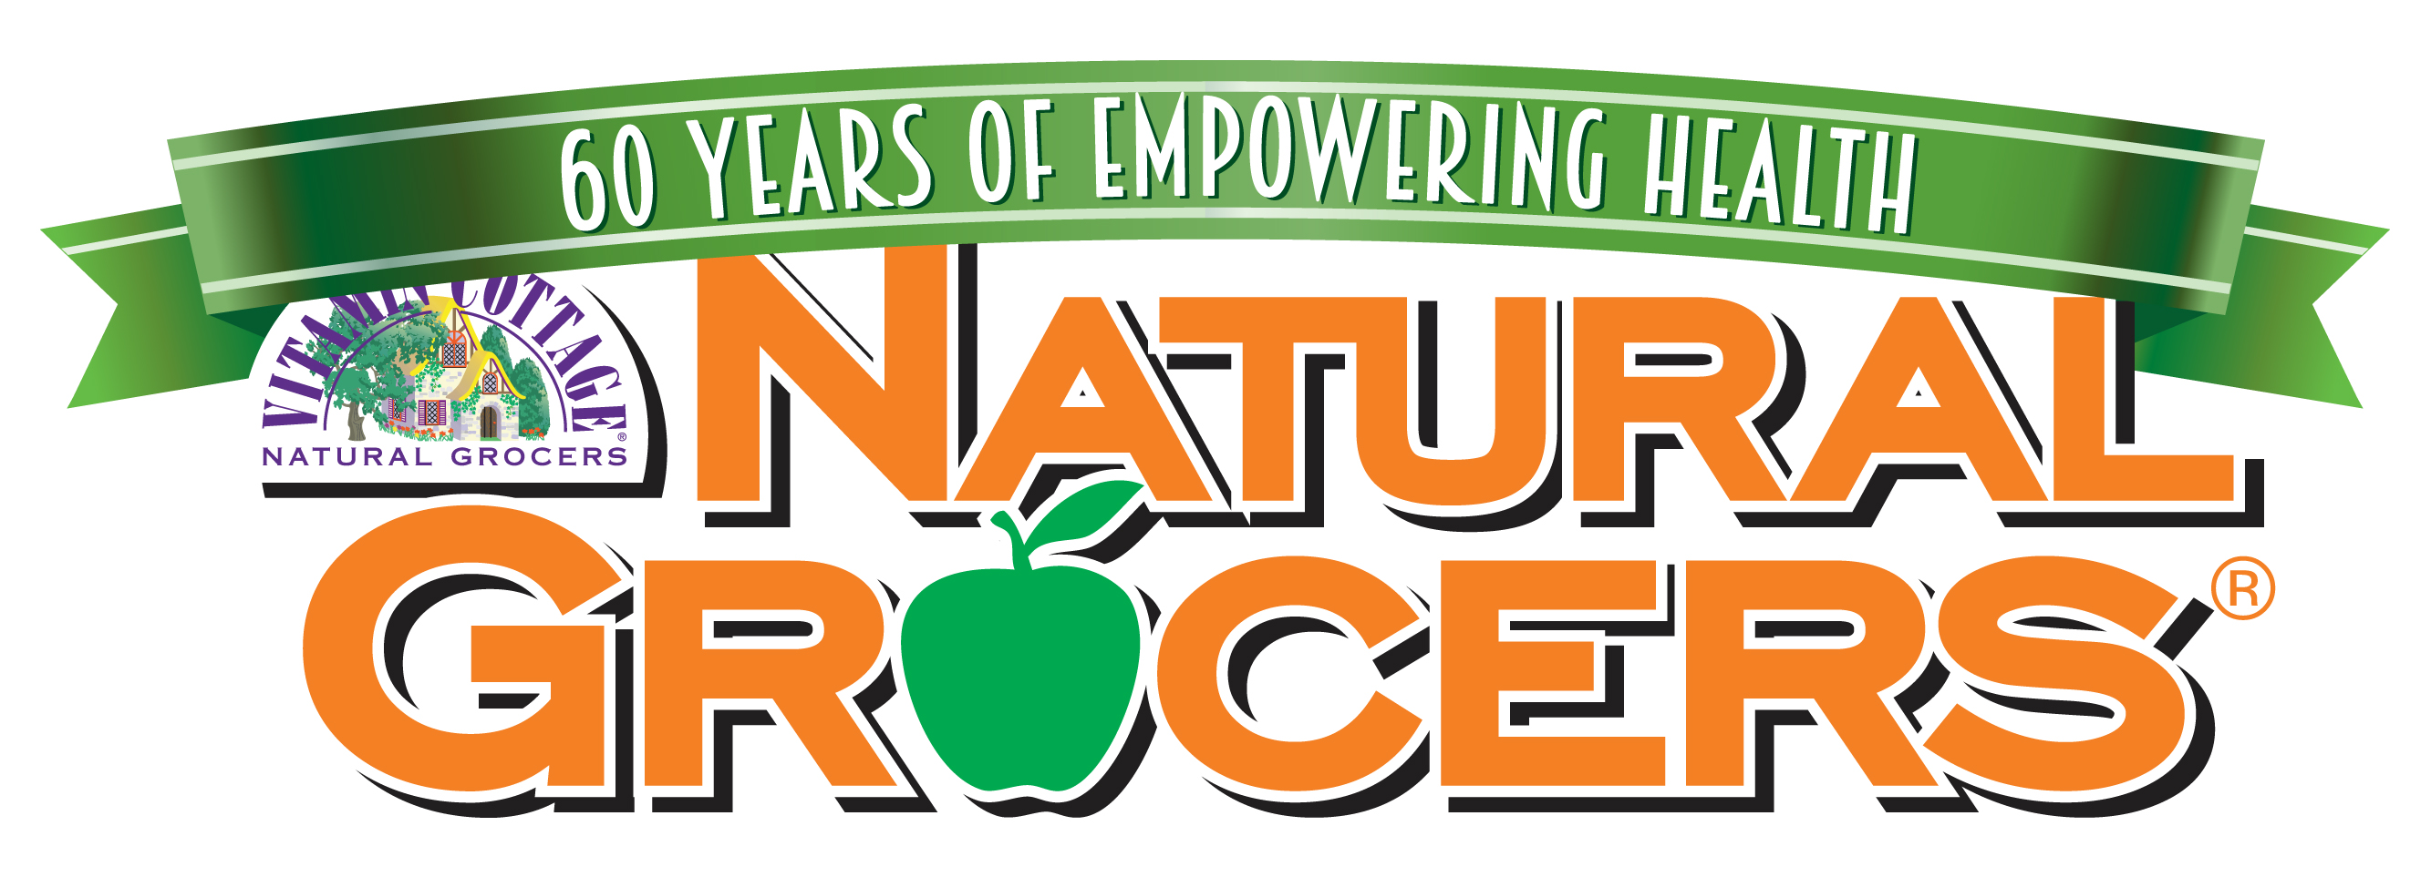
Body Care Company Questionnaire

This Body Care Company Questionnaire is required for Natural Grocers to review your company’s body care line for possible approval.

Mandatory Requirements for all product submissions:
- Refer to the Website for Ingredients that we do not allow. If your product contains any of these ingredients they will not be reviewed.
- New Item Form: Fill in Pricing, Product stats and Discounts allowed. Please place a hard copy in the box with sample submittals and send an electronic copy to bodycare@naturalgrocers.com
- Samples: We do not accept mock ups. Please send a set of full size product samples. These must be production samples.
- Registered UPC’s must be on all product submitted.
- Certificate of Liability Insurance ($2 Million)
- All of the questions need to be answered thoroughly in order for your products to be considered for the review process.
- Please feel free to include any other information that you feel is pertinent.
- Product is Reviewed 1x per quarter. You will be notified via email on the outcome.

Visit our website to review the product submission criteria prior to submitting your products: http://www.naturalgrocers.com/products/haba-product-criteria

Company Name: ________________________________________
DBA if applicable: _______________________________________
Company Phone: ________________________________________
Contact Name: __________________________________________
Contact Email: __________________________________________
Contact Phone: __________________________________________
Website Address if available: ______________________________

- Have you or your manufacturer been certified by a third party such as USDA Organic, USP, Oregon Tilth, Ecocert, CCIC Leaping Bunny Program, GFCO Gluten Free Certification Organization, NFCA National Foundation for Celiac Awareness, NSF/ANSI 305, USDA NOP, etc?

- Are you listed as a GMP Certified Company? Has the manufacturer if separate and your facility been audited for GMP if not listed as GMP certified?

- If not listed as a GMP Certified Company outline below the quality steps taken both in manufacture and distribution. Some questions to answer are: How does the manufacturer quantify quality standards? Who sets the standards of quality that are in place? What is done about contaminants of raw material and finished product?

- Do you manufacture your own products? If so, please provide location (warehouse facility, factory, etc.) and address of manufacturing. We will not approve anything that is not manufactured in a certified and inspected facility.

- What kind of warehouse controls do you have?

- How often is the manufacturing equipment cleaned?

- How are raw materials handled (by your manufacturer if you don’t manufacture yourself)? Is there vendor certification? Does the manufacturer verify the certificates of analysis of the raw materials?

- Do you use preserved raw ingredients and if so, do you fully disclose this?

- Does your product contain herbs that are imported from China?

- If your product contains herbs that are imported from China, how do you guarantee that they are not contaminated? What third party testing is done on the initial herbs? What finished product testing do you do? ALL TEST RESULTS MUST ACCOMPANY THIS DOCUMENT. Failure to provide this documentation could result in your product or entire line being denied approval, even if we have previously carried the product or other products in the category.

- What is your product preservative system? What percentage of the formula is it? Do you fully disclose this on your product packaging?

- Have you reviewed the list of ingredients that we will not accept on our website? Please confirm that your products do not contain any of these ingredients prior to submission. Also be aware that we do not accept multi-level products.

- Who does your formulating? What kind of credentials do they have?

- What kind of quality testing is performed? Please provide sample data pertinent to product being submitted for approval. An example would be an HPLC, UV/VIS, GC etc. Is there a finished product approval process?

- Do you perform your own quality testing in an in-house lab or do you use a contract lab? Who sets the standards of quality of each product and what are the standards? Feel free to use a separate sheet if needed.

- Do you code or mark expirations on your product? If coded, how is it decoded? What is the expected shelf life?

- Do you have liability insurance? We require a minimum $2 million policy to be on file with our company and updated yearly. It must cover all products that you sell. If mailed separately please send attn: Purchasing - Body Care

- We need to know how the product is going to be marketed:
- Is there going to be national advertising?
- Is there co-op money available to market it in our newsletter?
- Will there be demo support, testers and or samples?
- We need to know which retailers stock the product in our marketplace.

- What kind of return policy does your company have? At Natural Grocers we have a 100% customer return policy and expect the same from our vendors.

