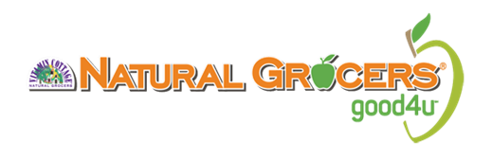
Hello,
Thank you for reaching out. We are always interested in partnering with new and exciting brands and hearing about new additions to your line! To be considered, all products must meet our high-quality product standards and should not contain ingredients we do not allow. Click HERE to view the Things We Won’t Carry and Why.

For all new item submissions and line extensions, please follow the steps below.

- To get started, please fill out the New Item Form attached and email to
NewItemsFood@NaturalGrocers.com. Be sure to include your brand name in the subject line. Paper copies will NOT BE ACCEPTED, you must send electronically.
  - Tab 1: Questionnaire
    - Please fill out all requested questions o Tab 2: New Item Form
    - Please complete the highlighted fields to the best of your knowledge o Tab 3: Ingredient list
    - Send a full ingredient list for all new items you are submitting for review o Tab 4: Natural Grocers store list
    - For your reference o Tab 5: New Item Review Schedule
- Ship live samples to the address below. Your items will be presented to our New Items Committee upon arrival.
  - Please note, we do not accept mock ups. Please send a set of full size product samples. These must be production samples.
  - Registered UPC’s must be on all product submitted.
    - New items and line extensions are presented to our New Items Approval Committee once a month. Once your items have been presented, I will reach out to you with a status update. Please do not reach out after the monthly review dates inquiring about an approval – I will be in contact with you.
    - If you are sending PERISHIBLE items, please clearly mark the outside of the package.

Natural Grocers
Attn: Jessica Veit/New Item Review
4403 Table Mountain Drive
Golden, CO 80403

Due to the overwhelming volume of new product submissions, we cannot guarantee you will receive a quick response. The new item review process typically takes up to 90 days or longer for animal products (dairy, meat, seafood, etc.). Providing complete and accurate information in your response can help to expedite the process. Please do keep in mind that products are reviewed monthly and it may take a few weeks before you receive an update. Please refrain from contacting us asking if we’ve received your submittal and sample delivery directly after your submittal – we will reach out to you. Again, the new item review process can take up to 90 days.
Thank you,
Jessica Veit

** Do not subscribe jveit@naturalgrocers.com or newitemsfood@naturalgrocers.com to your distribution lists and email blasts – we do not authorize this **

