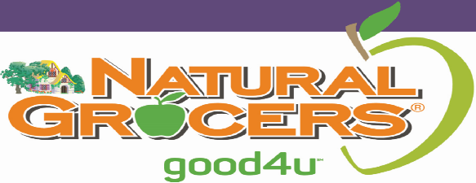

Supplement Product Submittal Criteria

Thank you for the interest in a partnership with Natural Grocers (NGVC)! Before we officially review products for possible placement in NGVC stores, we need to make sure product meets NGVC quality standards. Please complete a review package, which includes live samples to be shipped to the address listed below. Additionally, all forms and supporting documentation must be emailed.
Before proceeding with a submittal please note:
- Please review the Supplement Ingredients We Won’t Sell list posted on this website, www.naturalgrocers.com/what-we-wont-sell-and-why . We are unable to review any product containing these ingredients.
- Products from multi-level marketing or independent distributors will not be approved.
Samples:
Please send a physical sample of the product with finalized labeling containing “live” product. We use finished product samples to examine ingredients, label, packaging, size, flavor, smell, effect, etc. In addition, ensuring we have the final sample allows us to accurately set-up product in our POS system if it is approved in the future.

Samples are to be sent to:

Supplement Review
Natural Grocers
4403 Table Mountain Drive, Ste. A
Golden, CO 80403

Electronic Forms section:
Please review the list of forms and documents. Typically, the best person to complete the NGVC Quality Questionnaire (QQ) would be a QA person from your or your manufacturer’s team. In order to prevent waste, we would appreciate all forms and associated documents to be submitted only electronically to:

New Items Supplement newitemssupplement@naturalgrocers.com

Existing Vendor submittal packet:
- Please submit live product and new item forms as specified above.
- Any line extensions, changes to product formulas, reinstatement of previously discontinued products etc. must be submitted as new products for consideration. They are not automatically approved.
- Please provide suggestions of slower selling product within your line to potentially be discontinued for placement of new product.
For both New and Existing Vendors: Inadequate submittal packets, meaning missing forms, tests and samples will mean automatic non-approval of products or line. Please make sure the submittal includes all requested information.

New Vendor Submittal packet:
- NGVC Quality Questionnaire (QQ): one questionnaire per brand
- Prospective Vendor Details form to be completed
- Pricing form to be completed
- A certificate of liability insurance for direct purchase products with Vitamin Cottage Natural Food Markets Inc. dba Natural Grocers by Vitamin Cottage as the certificate holder and at least $2 Million aggregate (If approved, this will need to be updated annually). **At this time NGVC does not need to be listed on a COI. A copy of a current COI would be suitable for review purposes.
- A proposed marketing plan including national advertising or co-op dollars available.
- From QQ, provide any supporting documentation regarding Supplier Verification Program.
- From QQ, provide any quality supporting documentation.
Forms – Please visit www.naturalgrocers.com/supplement-product-criteria for downloads

